**Data Pipeline Architecture**

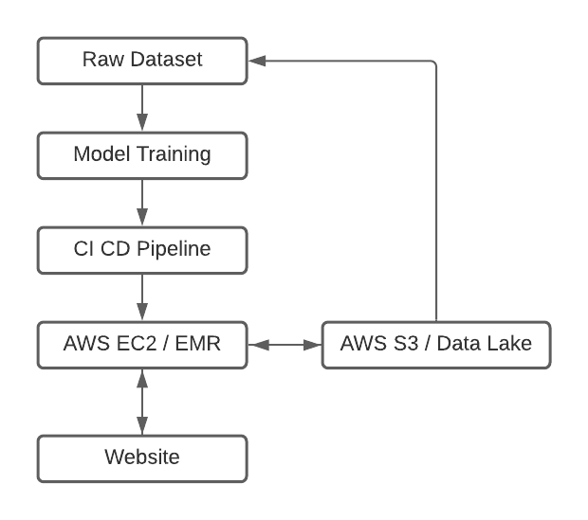

1. Model training will happen on server
2. You can save model using pickle (.pkl)
3. Host model at server side using Flask/Django (exposed as API)
4. API can be hit through application.
5. Save o/p & raw data in DB/AWS S3/etc. for future re-training.
6. Retrain model based on the new data (from source which is stored in storage such as S3).

For this assignment purpose, I have used

* my local machine for model training
* use Heroku (provides PAAS) for CI CD
* hosted on Heroku

Please visit <https://predict-ez-car-rental-price.herokuapp.com/> for getting the journey price quote.